# Numpy

1. **Concatenating two arrays:**

We have two arrays np arrays X and W0 with size (569,30) and (30,1) respectively.

Such that

**X = x1, x2, x3……xn --- features vector**

**W = w0, w1, w2………wn --- Weights vector**

**W0 = Vector with all one’s of size (30,1)**

Here what we want is to concat W0 with X such that the size of X becomes (569,31).

That is here we are adding W (all one’s) to our features array X such that each of our record becomes an array of **(x0, x1, x2 ………xn)**

**So, this would help when doing w0 + w1x1 + w2x2 + ……… + wnxn.**

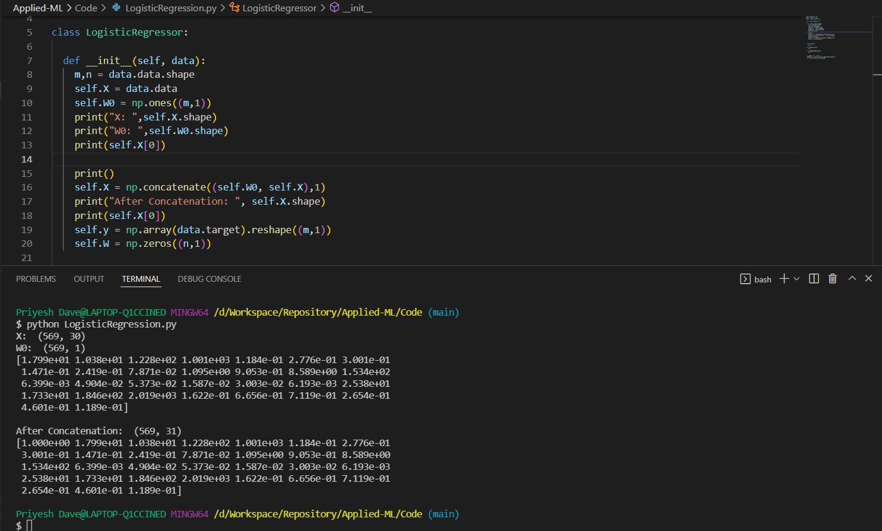

1. **np.fill_diagonal():**

We can use np.fill_diagonal(matrix, list) to fill the diagonal of matrix with the values of list.